**AIAC LAB TEST-1**

**TASK-1**

**Write a Python code to calculate the sum of odd and even numbers in a given list using GitHub Copilot along with VS Code. Use zero shot prompting.**

**PROMPT:**

**create a Python code to calculate the sum of odd and even numbers in a given list and read the values from the console.**

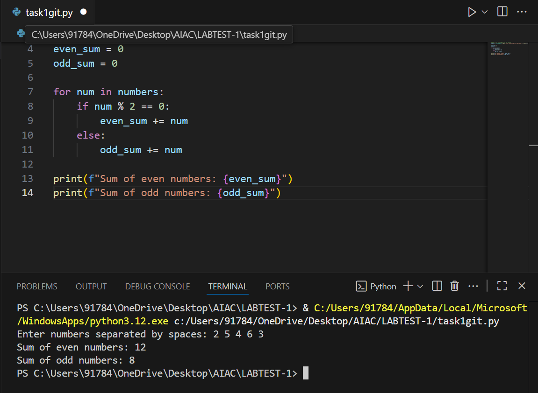

**TASK 2:**

**Write a Python code for given a list of integers, remove duplicates and print the sorted result. GitHub Copilot along with VS Code. Use one shot prompting.**

**PROMPT:**

**Create a Python code for given a list of integers, remove duplicates and print the sorted result and read the values from the console. for example:input: enter integers : 12, 13, 12, 15, 18, 15 output:the sorted list is:12, 13, 15, 18**

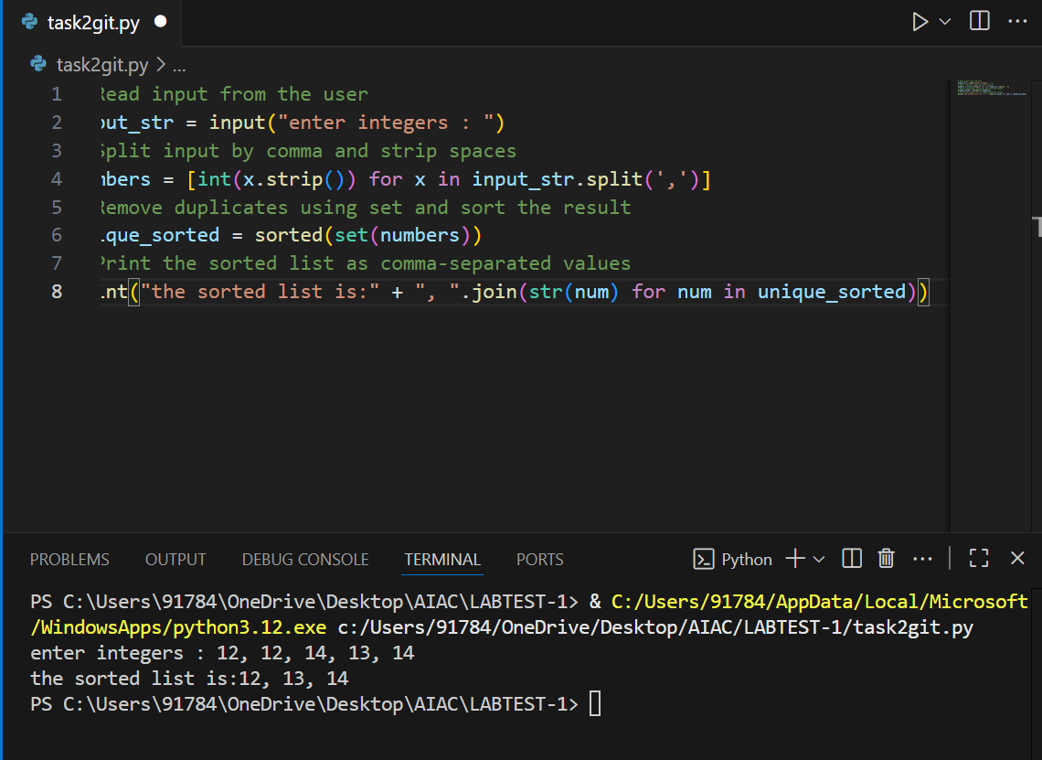

**TASK 3:**

**Write a Python function that converts the temperature between Celsius, Fahrenheit, and Kelvin based on user choice. Use the Cursor AI tool. Use few shot prompting.**

**PROMPT:**

**create a Python function that converts the temperature between Celsius, Fahrenheit, and Kelvin based on user choice. read the values from the console. For Example: 1. Temperature Converter**

**Choose the input unit:**

**1. Celsius**

**2. Fahrenheit**

**3. Kelvin**

**Enter the number corresponding to the input unit: 1**

**Enter the temperature value: 35**

**Choose the output unit:**

**1. Celsius**

**2. Fahrenheit**

**3. Kelvin**

**Enter the number corresponding to the output unit: 2**

**Converted temperature: 95.00 Fahrenheit 2.Temperature Converter**

**Choose the input unit:**

**1. Celsius**

**2. Fahrenheit**

**3. Kelvin**

**Enter the number corresponding to the input unit: 2**

**Enter the temperature value: 35**

**Choose the output unit:**

**1. Celsius**

**2. Fahrenheit**

**3. Kelvin**

**Enter the number corresponding to the output unit: 1**

**Converted temperature: 95.00 Celsius**

**3.Temperature Converter**

**Choose the input unit:**

**1. Celsius**

**2. Fahrenheit**

**3. Kelvin**

**Enter the number corresponding to the input unit: 1**

**Enter the temperature value: 40**

**Choose the output unit:**

**1. Celsius**

**2. Fahrenheit**

**3. Kelvin**

**Enter the number corresponding to the output unit: 3**

**Converted temperature: 313.15 Kelvin repeat the loop and exit when the user wants**

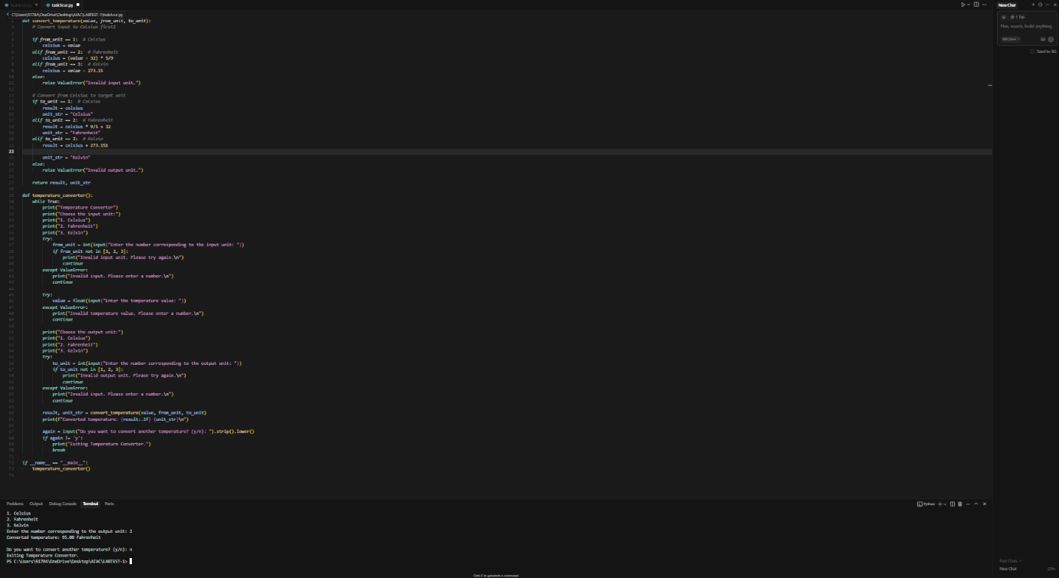

**TASK4:**

**Write a Python function to remove punctuation, convert to lowercase, and remove stop words from a given text. Use the Cursor AI tool. Use zero shot prompting**

**PROMPT:**

**create a Python function to remove punctuation, convert to lowercase, and remove stop words**

**from a given textread the value from the console.**

